1. 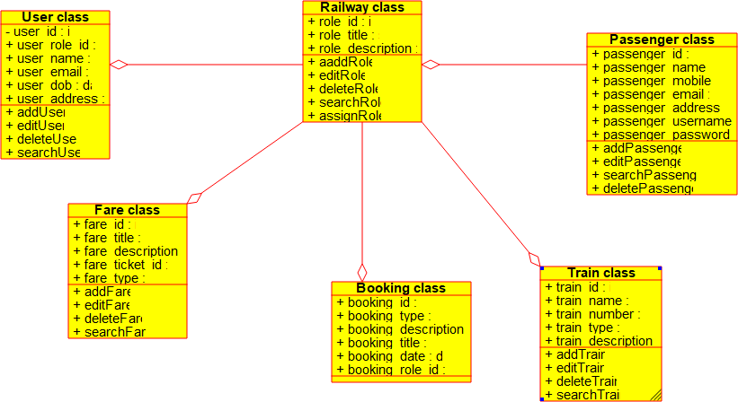**Class Diagram**
2. 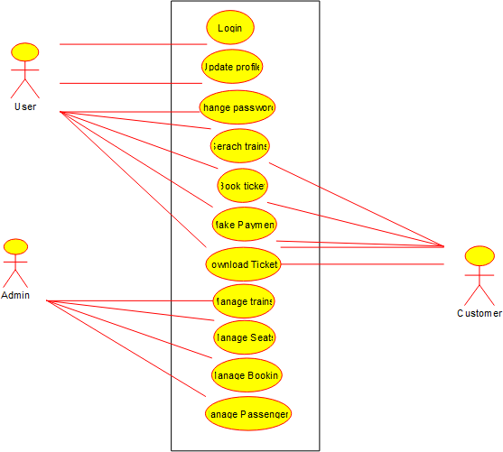**Usecase Diagram**
3. **Sequence Diagram**
4. Railway Reservation System

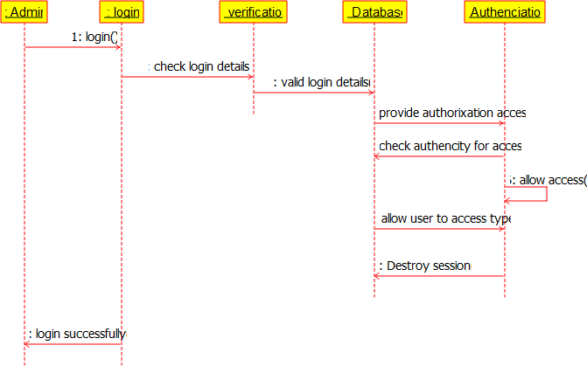

1. **State Diagram**

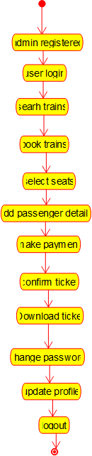

1. **Activity Diagram**

